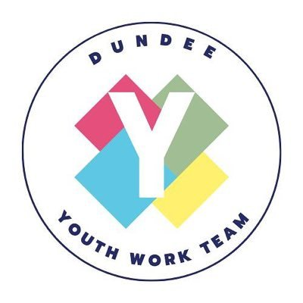

Dundee Youth Fund (Currently)

The Dundee Youth Fund awards grants to projects and activities that support the development of learning opportunities in Dundee for young people aged 10 to 26 who live, work or study in Dundee.

Priority is given to applications that:
- increase employability skills;
- increase awareness of physical and mental health;
- develop personal and social skills;
- develop entrepreneurial skills and social enterprises;
- encourage young people to be active outdoors;
- encourage young people to take care of the natural environment; and
- promote and enable equal access to opportunities.

Each individual can apply to the Dundee Youth Fund twice in one financial year (April to March) and each organisation once. There are three levels of award:

Piggy Bank: Small grants up to £500.
Money Box: Medium grants between £501 and 2000.
The Vault: Large grants between £2001 and £5000.

Youth Work Involving Young People in Decision Making in a CLD Context in Dundee
Focus Statement

Within CLD Youth Work we have a vision and commitment to ensure that children and young people are engaged in shaping policy and service delivery in areas of concern to them as a matter of principle and that these opportunities are embedded in everyday practice.

The United Nations Convention on the Rights of the Child states that children and young people have the right to have their views taken into account in decisions made about matters that affect them and that, adults in a position to help them have a duty to provide them with support

AIMS: WHAT WE WANT TO ACHIEVE

Effective Contributors
- Young people participate safely and effectively in groups (4) Outcome Indicators: 1. Young people regularly attend a group. 8. Young people shape the direction or progress of the group.
- Young people express their voice and demonstrate social commitment (6) Outcome Indicators: 1. Young people participate in the decision-making process. 13. Young people feel part of their community.

Participatory budgeting (PB) is a democratic process in which citizens decide directly how to spend part of a public budget. We support PB as a tool for community empowerment and as a resource to build on the wider development of participatory democracy in Scotland.

1. Ideas are generated about how a budget should be spent.
2. People vote for their priorities.
3. The projects with the most votes gets funded.

Participatory budgeting with, and by, young people can have many benefits both for the local communities they live in but also for the young people themselves. PB has an educative element built in which can help young people ‘learn about democracy by taking part’ and support their local community by becoming active members of their communities by coming together, sharing ideas, designing, planning, deliberating and prioritising ideas for the benefit of the community. Including young people in democratic decision making can help build social cohesion through developing shared visions and aspirations, in some ways this can also help to shape a genuine shift in power to the people that these decisions directly impact, in this case young people themselves.

Participatory budgeting began in Porto Alegre in Brazil in 1989 and was credited with shifting priorities to better support the poorest parts of the city, improving services, improving infrastructure, strengthening governance, and increasing citizen participation.

Participatory planning is a process by which a community undertakes to reach a given socio-economic goal by consciously diagnosing its problems and charting a course of action to resolve those problems.

Potential Methods of Engagement

Dundee Decides 2018

Dundee Decides was an opportunity to decide how Dundee City Council should spend the £1.2 million Community Infrastructure fund. Each of the council’s eight electoral wards – Strathmartine, Lochee, West End, Coldside, Maryfield, North East, East End and The Ferry – were allocated up to £150,000 to spend on infrastructure improvements. Residents were able to vote using an electronic voting system which incorporated two passwords and encryption.

Participatory budgeting.
Participatory planning.

Central, West, and East Youth Teams

Explain what participatory budgeting is and what it means for young people.

Consult with young people around how they would like to spend this money. Should it remain a grant application process by individuals and groups or should we split the money equally in each of the geographical youth team areas/voluntary sector/council ward boundaries/parliamentary boundaries. Should we ask young people, in collaboration with the youth teams/voluntary sector, to identify projects or areas for improvement within their communities which they can then vote on with the most votes being the winner, similar to Dundee Decides.

Local Youth Forums

A youth forum is run and developed by young people for young people with appropriate support from Youth Workers. Youth forums represent the views of young people, giving young people the opportunity to have a voice, discuss issues, engage with decision makers and contribute to improving and developing services for young people through processes like participatory budgeting.

Dundee Youth Work Network

Consult with young people via the network around how they would like to spend this money. Should it remain a grant application process by individuals and groups or should we split the money equally in each of the geographical youth team areas/voluntary sector/council ward boundaries/parliamentary boundaries.

Consultation Link

https://forms.office.com/r/6SmFK3sZ6x

