
Alzheimer Scotland (Dundee)
Autumn 2025 - Newsletter
_______________________________________________________________________________________
Following a lovely summer; we wander into Autumn. As many of you are aware, due to funding cuts, the Daycare service which ran from our Dementia Resource Centre in Stobswell ended at the end of June. I am pleased to say that the staff who worked within this service are now in new roles out in the community and many of the volunteers who supported that service have been engaging in our activities out in the community. Whilst this has had an impact, I want to reassure that Alzheimer Scotland is still present in the city and Dementia Advisor services, Carer support and Community engagement is still on-going. Please find some of our upcoming activities and services listed in this newsletter and I look forward to seeing you out & about.

On the subject of funding, as an organisation, we rely on donations to continue our work. If there is no specified cost for an activity, we ask for a donation (suggested donation £3 pp) this enables us to continue to provide activities and services in the community.

As always, if you have a query, just get in touch:
Jeni Sinclair – 07917 241024 Jenisinclair@Alzscot.org
____________________________________________________

TIMEX Group
We are delighted to highlight our TIMEX activity. Having started in July at the Dementia Resource Centre in Dundee. The “Ticky TIMEX” activity, is supported by the Timex Group. All the group members are either former employees or associates who have accumulated a treasure trove of photos, pictures, products and artefacts from the factory over the years.


Sessions are a walk down the TIMEX memory lane, an allow an opportunity to share stories and tales. We are delighted that the gents are making this a regular date in the diary.

Sessions for Sept & October are:
Dates: Wednesday 24th September & Wednesday 22nd October 2025
Time: 2pm – 3.30pm
Where: Alzheimer Scotland Resource Centre, 9 Morgan St. Dundee

To join in, please contact: Jeni Sinclair – jenisinclair@Alzscot.org

V&A Tours & Workshop
The popularity of the current Garden Futures: Designing with Nature tour & workshop goes from strength to strength

Facilitated by colleagues at V&A Dundee the session involves a guided tour of Garden Futures:
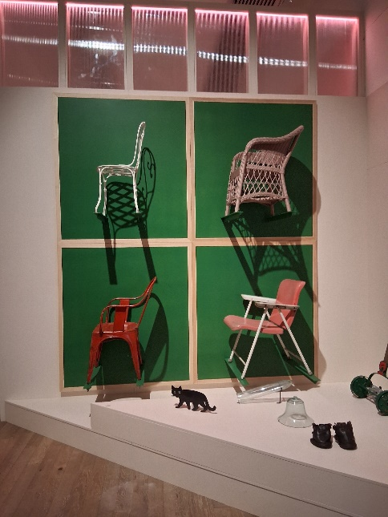
Designing with Nature exhibition, which includes an exhibit of the upcoming Eden Project transformation of a former Brown site on Dock Street.

This is a lovely exhibition and one that will suit folks, even if you haven't green fingers!!

A creative workshop is included in the session and refreshments are also provided.

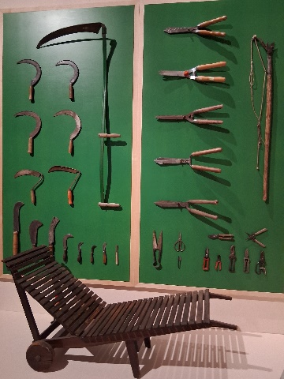
Due to the popularity of these sessions and to provide a comfortable environment for all, there are 15 places per group.

The sessions take place from 10.30am – 12.30pm.

Please find dates for the rest of 2025:
Thursday 2nd October
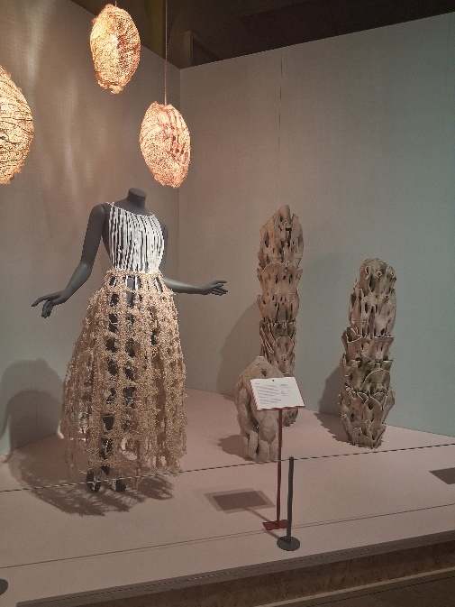
Thursday 6th November
Thursday 4th December

We shall be asking for a donation for these sessions.

Please note that places need to be booked ahead

To book your space, please contact Jeni Sinclair – jenisinclair@alzscot.org


Bitesize Information Sessions - Traits & Behaviours associated with Dementia
We are pleased to offer the following bitesize information session in October – Understanding Traits & Behaviours associated with Dementia. The format will include both an in-person option and a digital option via Microsoft TEAMS. Please note that both options contain the same information.

Looking at the varying symptoms associated with the condition, the session will look to offer guidance, direction and understanding of how to support an individual with a Dementia diagnosis and also tips for the carer.

In-person option
Dates: Monday 6th October 2025
Time: 2pm – 3.30pm
Where: Alzheimer Scotland Resource Centre, 9 Morgan St. Dundee

Digital option
Dates: Thursday 30th October 2025
Time: 10.30am – 12.00noon
Where: Via Microsoft TEAMS

If you are keen to join in, please contact Jeni Sinclair – jenisinclair@alzscot.org and specify the option that you are keen to join
_____________________________________________________________________

Northend Sports D’cafe
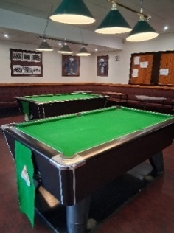
Our new Sports D’café has started within the Northend Sports Club in the Fairmuir area of Dundee; this venue has pool tables, darts & dominos, along with a cuppa or two.

We are delighted to be working with the team at Dundee Northend. The D’cafe will take place in the first floor Members lounge (please note that this is only accessible via stairs – there is no lift access).
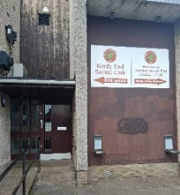
IG11 7RX, There is a small carpark at the club, with a further parking area situated between Fairfield Bowling Club and Dundee Northend – this should be accessed via Park Road and then Fairmuir Road

Tuesday 23rd September 2.00pm – 3.30pm
Wednesday 29th October 2.00pm – 3.30pm
If you are keen to join us, just pop along on the day!
_

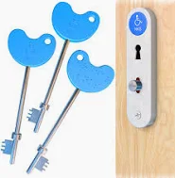
Radar Keys
At a carers group, the topic of RADAR keys came up – what is a Radar Key??
– it’s a key that allows access to disabled toilets (many of which are often locked to the general public as opposed to being open).

Spending a penny can become a challenge for those with Dementia and their carers. From getting disorientated in a strange environment to the carers needing to support with personal care.

The RADAR key allows access into a bigger toilet space, whereby a carer can support. These keys are available online for a few pounds and are a handy accessory to carry. Radar keys can be purchased in some chemists and online.

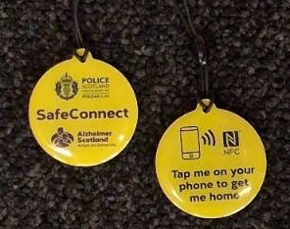
Safety in the Community - SafeConnect
We are pleased to highlight the relaunch of SafeConnect.

Safe connect is a distinctive fob which has been designed to support and maintain independence in people living with Dementia. Fitting onto keys, in a wallet or in a pocket this device, whilst not GPS, contains a small amount of information about the owner should they become disorientated out in the community. This information is accessed via mobile phone, by tapping the fob so that a phone call can be made to a next of kin in order to reunite them.

SafeConnect is programmed with the name of the owner, where they live (i.e. Dundee) a name and contact number for a next of kin or named person. There is no further information listed for safety and security purposes.

This incentive is in partnership with Police Scotland and has been undergoing trials and testing in parts of Scotland over the past couple of years

To access more information about SafeConnect, please contact Jeni sinclair – jsinclair@Alzscot.org / 07917 241024
_____________________________________________________________________

Clock changes – British Wintertime
Just a wee reminder that British Wintertime starts at precisely 2:00am on Sunday, 26th October 2025, when the clocks will go back one hour in the UK.


Carers Digital Group
Vaccinations-:
Consent & Authorisation
Our next group will take place on Monday 22 September (6.15pm – 7.15pm) via Microsoft TEAMS. The topic for this session is: Consent & Authorisation for Vaccination for individuals who are unable to consent for themselves. This session is supported by an NHS colleague from the Vaccination Service.

The session will offer information, and direction regards consent and authorisation for someone who can no longer consent for this treatment. We shall look at the importance of having a Section 47 Certificate of incapacity document in place and aspects relating to documentation that you should have when visiting a vaccination centre.

If you are keen to join us on the evening, please contact Jeni sinclair – jsinclair@Alzscot.org / 07917 241024
_____________________________________________________________________

Total Memories Choir – Autumn Concert
The Total Recall Memories Choir continues to go from strength to strength. Their next concert will take place at 7pm on Saturday 4th October at The Space performance theatre within the Dundee College, Kingsway Campus. Tickets can be purchased via Ticket Source:

Total Recall Memories Choir event tickets from Ticket Source: – www.ticketsource.co.uk/totalrecall
The members meet on a weekly basis (Friday afternoons) in central Dundee.

Anyone keen to find out more about the choir and how to join – please contact TOTALMEMORIESCHOIR@OUTLOOK.COM

5 Minute Teaser - Autumn wordsearch
Find the 20 Autumn related teasers in the wordsearch.

 |  | V | P | C | R | I | S | P | L | E | A | V | E | S | A | P | G
 |  | O | E | B | A | A | N | K | R | A | Q | W | B | F | Y | S | U
 |  | O | N | B | O | N | F | I | R | E | S | A | A | A | M | P | Y
 |  | E | N | W | D | F | V | S | R | D | B | U | R | Q | D | I | F
 |  | M | Y | A | P | A | R | K | I | N | A | O | H | Y | J | N | A
 |  | A | F | V | G | O | I | F | K | J | J | M | T | E | C | R | W
 |  | T | O | F | F | H | K | L | A | K | L | B | P | C | L | U | K
 |  | G | R | O | S | E | L | P | P | A | E | E | F | F | O | T | E
 |  | C | T | L | B | P | D | C | B | E | V | T | L | I | C | S | S
 |  | O | H | I | D | O | O | K | I | N | C | S | B | R | K | C | S
 |  | N | E | A | G | S | E | Z | I | E | A | N | D | E | S | S | S
 |  | K | G | G | N | D | N | Y | S | A | T | A | E | W | C | A | P
 |  | E | U | E | A | I | A | G | A | S | G | A | Y | O | H | U | U
 |  | R | Y | J | K | Z | K | U | P | B | N | T | N | R | A | K | Y
 |  | S | D | M | C | A | H | I | O | M | N | R | X | K | N | B | S
 |  | J | U | M | L | Y | Z | S | L | C | E | B | O | S | G | M | O
 |  | P | X | U | H | K | P | I | I | W | N | E | A | C | E | N | C
 |  | C | A | U | T | U | M | N | S | G | N | I | V | R | A | C | A
 |  | D | A | L | I | O | M | G | N | A | A | Q | R | Q | W | S | U
 |  | A | A | F | B | H | X | F | N | E | E | W | O | L | L | A | H

PUMPKIN HALLOWEEN DOOKIN CARVING
PARKIN OCTOBER PENNY FOR THE GUY TURNIPS
GUISING FIREWORKS CRISP LEAVES FOLIAGE
TOFFEE APPLES CONKERS ACORNS COSY UP
AUTUMN GUY FAWKES CLOCKS CHANGE BONFIRE
_____________________________________________________________________

For further information regards any of our services/activities.
please contact:

Jeni Sinclair – Dementia Advisor
07917 241024 / jenisinclair@Alzscot.org


